1

100000007



2

100000008

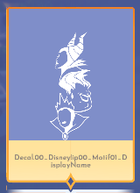

3

100000009

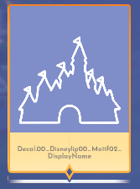

4

100000010

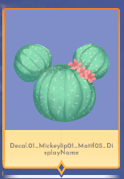

5

100000011

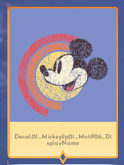

6

100000012

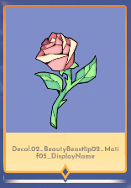

7

100000013

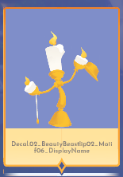

8

100000014

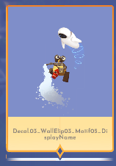

9

100000015

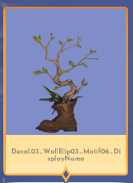

10

100000016

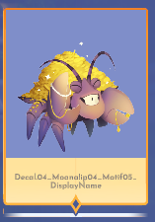

11

100000017

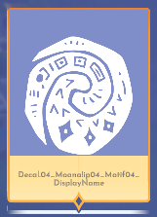

12

100000018

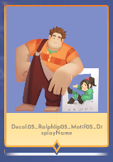

13

100000019



14

100000020

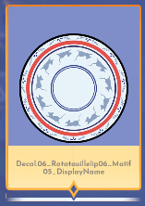

15

100000021



16

100000022

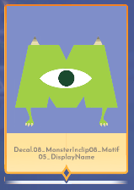

17

100000023

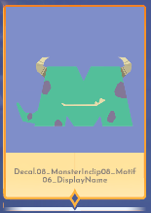

18

100000024

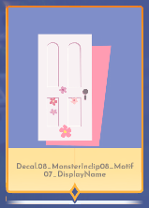

19

100000025

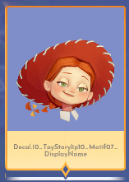

20

100000026



21

100000027

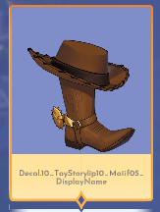

22

100000028

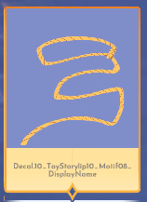

23

100000029

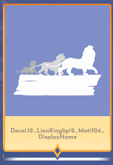

24

100000030

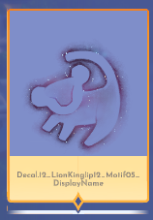

25

100000033

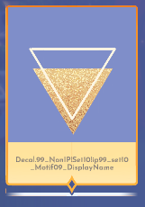

26

100000034

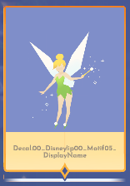

27

100000035

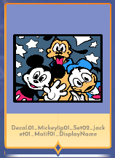

28

100000036

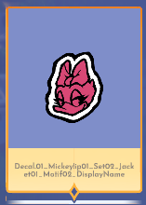

29

100000037

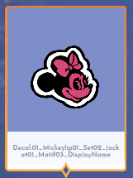

30

100000038

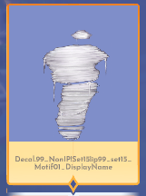

31

100000039

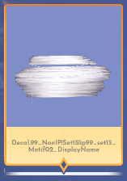

32

100000040

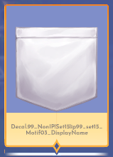

33

100000041

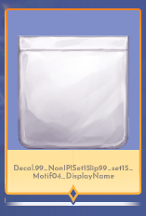

34

100000042



35

100000043



36

100000044



37

100000048

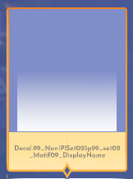

38

100000049

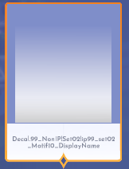

39

100000051

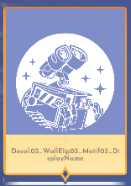

40

100000052



41

100000053



42

100000054

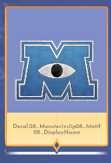

43

100000055



44

100000056

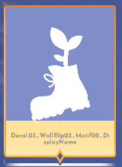

45

100000061

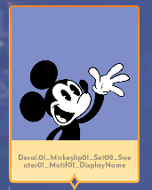

46

100000062

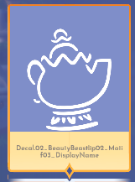

47

100000077

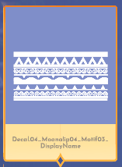

48

100000078



49

100000080

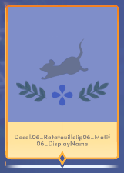

50

100000081

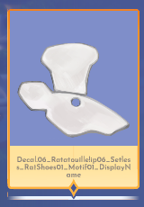

51

100000082

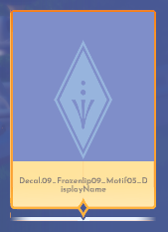

52

100000083



53

100000084

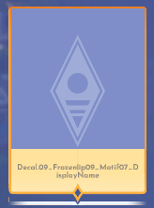

54

100000085

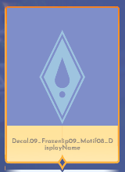

55

100000086

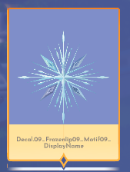

56

100000163

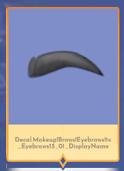

57

Motif tiu Patinhas

100000166



58

Mickey Mouse Nivel 6

100000167



59

Orelhas de mickey

100000168



60

100000169

Rosto Mickey



61

100000170

Laço Minnie Nivel 3 de amizade dela

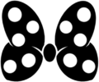

62

100000171

Gota de chuva (Padrão)



63

100000172

Rosa da Bela e a Fera



64

100000173

Rosto da fera (Desbloqueado por padrão)



65

100000174

Espelho a Bela e a fera



66

100000175

Rosa dentro do pote fino

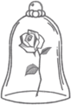

67

100000176

Rosa



68

100000177

Moana Level 3



69

100000178

Ralph Liberado por padrão



100000179 - nao aparece nada

70

100000180

Ralph pose



71

100000181

Coração Pixelado



72

100000182

Biscoito meu herói



73

100000183

Ratatui simbolo - Remy level 3



74

100000184

Simbolo ratatui - desbloqueado por padrão



75

100000185

Panelas Remy

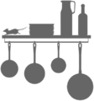

76

100000186

Sapatinho cinderela



77

100000187

Carruagem liberada por padrão



78

100000188

Varinha magica desbloqueada por padrão

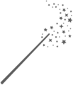

79

100000189

Castelo Cinderela



80

100000190

Sapatinho de cristal na almofada



81

100000191

Cinderela na bolha



82

100000192

Monstros s.a simbolo de raiva



83

100000193

Simbolo monstros s.a liberado por padrão



84

100000194

Mike wazowski



85

100000195

Mike sorrindo



86

100000196

Floco de neve frozen desbloqueado por padrão



87

100000197

Elsa level 6

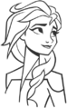

100000198 - nao aparece nada

88

100000199 - cavalo elsa level 9



89

100000200 - Alien Toy Story

Desbloqueado por padrão



90

100000201 - Simbolo Buzz Lightyear

Desbloqueado por padrão



91

100000202

Bolinha Toy Story



92

100000203

Pizza Planet



93

100000204

Sol Rapunzel

Desbloqueado por padrão



94

100000205

Lanternas rapunzel desbloqueado por padrão



95

100000206

Varias lanternas rapunzel

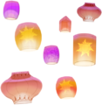

96

100000207

Simba - liberado por padrão



97

100000208

Simbolo simba bordado liberado por padrão

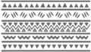

98

100000209

Patinhas Simba



99

100000210

Garfo Ariel nivel 3



100

100000211

Bolhas ariel nivel 6

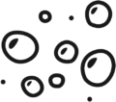

101

100000212

Conchas do colar da vanessa/ursula level 3



102

100000213

Ariel



103

100000214

Ondas do mar ariel



104

100000215

Ariel level 9



105

100000216

Caveira pirata (aba dos gerais não da coleção do filme)



106

100000217

Espada - Motifs gerais



107

100000218

Leme Pato donald level 3



108

100000219

Pratos mágicos - A espada era a lei

Liberado por padrão



109

100000220

Stitch comemorando

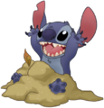

110

100000221

Stitch tocando musica na vitrola

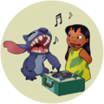

100000222 - não aparece nada

111

100000223 - Castelo lgbt

Motifs diversos



112

100000224

Tefiti - Moana



113

100000225

Nuvens em pixel



114

100000226

Doces ralph

Liberados por padrão



115

100000227

Chapéu Ratatui



116

100000228

Remy comendo

Level 6

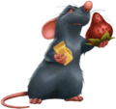

117

100000229

Placa restaurante level 9

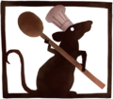

118

100000230

Ana Nivel 3



119

100000231

Patinho fofo - gothel level 6



120

100000232

Flor Gothel nivel 9



121

100000233

Coroa Rapunzel

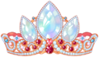

122

100000234

Insetos o Rei leão

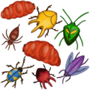

123

100000235

Mato verde



124

100000236

Tridente do tritão

Ursula level 6

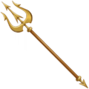

125

100000237

Coroa da ursula

level 9 dela



100000238 - não aparece nada

100000239 - Não aparece nada

126

100000240 - Espada Merlin

Merlin level 3



127

100000241 - Liberado por padrão Merlin



128

100000242 - Simbolo havaiano Lilo e stitch



129

100000243 - Flower Lilo e Stitch



130

100000244 - Folha liberada por padrão lilo



131

100000245 - Stitch Cantor

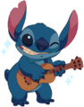

132

100000246

Foto de familia da Lilo

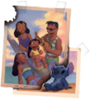

133

100000247

Fofucho

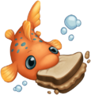

134

100000248

Stitch e tartaruga liberado por padrão

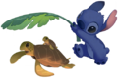

135

100000249

Bolinha - diversos



136

100000250

Bolinha aberta - diversos



137

100000251

Quadrado

Diversos



138

100000252



139

100000253



140

100000254



141

100000255



142

100000256



143

100000257



144

100000258



145

100000259



146

100000260



147

100000261



148

100000262



149

100000263



100000264 - não aparece nada

100000265 - não aparece nada

150

100000266



151

100000267

Simbolo de visto

Não encontrei a coleção relacionada



152

100000268

Coração



153

100000269

Flor



154

100000270

Flor belissima outros



155

100000271

Sakuras



156

100000272

Flor outros

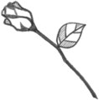

157

100000273

Sakura



158

100000274



159

100000275



160

100000276



161

100000277



162

100000278

Planetas - Outros



163

100000279



164

100000280



165

Simbolo diferente - Outros

100000281



166

100000282

Laranjas

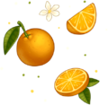

167

100000283



168

100000284



169

100000285



170

100000286



171

100000287

Nuvem

SC



172

100000288



173

100000289



174

100000290

Cogumelo



175

100000291

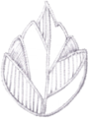

176

100000292

Rajah - SC



177

100000293

Corvo preto

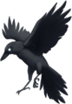

178

100000294



179

100000295



180

100000296



181

100000297

Coração pedra preciosa



182

100000298



183

100000299

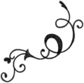

184

100000300

Não tem na wiki!

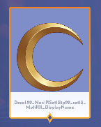

185

100000301

Não tem na wiki

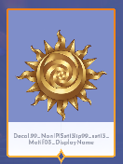

186

100000302

Não tem na wiki



187

100000303

folha escura -

n t wiki

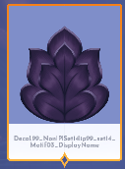

188

100000304



189

100000305



190

100000306



191

100000307



192

100000308



193

100000309

cinderela



194

100000310



195

100000311



196

100000312

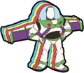

197

100000313



198

100000314



199

100000315



200

100000316



201

100000317



202

100000318



203

100000319



204

100000320



205

100000321



206

100000322



207

100000323



208

100000324

goofy level 6

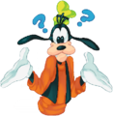

209

100000325



Donald level 9

210

100000326

Mickey level 3



211

100000327

Minnie Level 6

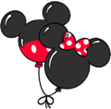

212

100000328

Donald Level 6



213

100000329



Pateta Level 3

214

100000330

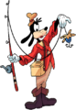

Pateta Level 9

215

100000331

Tiu patinhas nivel 9

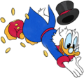

216

100000332

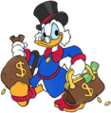

Tiu patinhas nivel 3

217

100000333

Tiu patinhas nivel 6



218

100000334

Mamae gothel level 3



219

100000335

Maui Level3



220

Moana level 9

100000336



221

100000337

maui level 9



222

100000338

Kristoff level 3

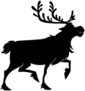

223

100000339

[Kristoff](https://dreamlightvalleywiki.com/Kristoff) Level 9

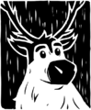

224

100000340

[Elsa](https://dreamlightvalleywiki.com/Elsa) Level 3



225

100000341

[Anna](https://dreamlightvalleywiki.com/Anna) Level 6



226

100000342

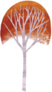

[Kristoff](https://dreamlightvalleywiki.com/Kristoff) Level 6

227

100000343



[Anna](https://dreamlightvalleywiki.com/Anna) Level 9

228

100000344



Não localizado no wiki!

229

100000345

[Merlin](https://dreamlightvalleywiki.com/Merlin) Level 6

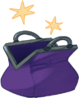

230

100000346

[Merlin](https://dreamlightvalleywiki.com/Merlin) Level 9

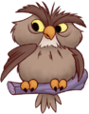

231

100000347



[Prince Eric](https://dreamlightvalleywiki.com/Prince_Eric) Level 3

232

100000348



[Prince Eric](https://dreamlightvalleywiki.com/Prince_Eric) Level 6

233

100000349



[Prince Eric](https://dreamlightvalleywiki.com/Prince_Eric) Level 9

234

100000350

[*Pixar Fest Star Path*](https://dreamlightvalleywiki.com/Pixar_Fest_Star_Path)



235

100000351



[***Pixar Fest Star Path***](https://dreamlightvalleywiki.com/Pixar_Fest_Star_Path)

236

100000352



[*Pixar Fest Star Path*](https://dreamlightvalleywiki.com/Pixar_Fest_Star_Path)

237

100000353



Não localizado na Wiki até agora.

238

100000354

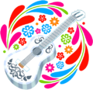

[***Pixar Fest Star Path***](https://dreamlightvalleywiki.com/Pixar_Fest_Star_Path)

239

100000355



[*Pixar Fest Star Path*](https://dreamlightvalleywiki.com/Pixar_Fest_Star_Path)

240

100000356



[*Pixar Fest Star Path*](https://dreamlightvalleywiki.com/Pixar_Fest_Star_Path)

241

100000357



[***Pixar Fest Star Path***](https://dreamlightvalleywiki.com/Pixar_Fest_Star_Path)

242

100000358



[*Pixar Fest Star Path*](https://dreamlightvalleywiki.com/Pixar_Fest_Star_Path)

243

100000359

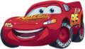

[*Pixar Fest Star Path*](https://dreamlightvalleywiki.com/Pixar_Fest_Star_Path)

244

100000360



[*Pixar Fest Star Path*](https://dreamlightvalleywiki.com/Pixar_Fest_Star_Path)

245

100000361



[***Pixar Fest Star Path***](https://dreamlightvalleywiki.com/Pixar_Fest_Star_Path)

246

100000362



[***Pixar Fest Star Path***](https://dreamlightvalleywiki.com/Pixar_Fest_Star_Path)

247

100000363



[*Pixar Fest Star Path*](https://dreamlightvalleywiki.com/Pixar_Fest_Star_Path)

248

100000364



DA ONDE VEIO ESSE DUG JESUS?

249

100000365



[Scar](https://dreamlightvalleywiki.com/Scar) Level 3

250

100000366

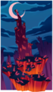

[Scar](https://dreamlightvalleywiki.com/Scar) Level 6

251

100000367

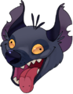

[Scar](https://dreamlightvalleywiki.com/Scar) Level 9

252

100000368 - NÃO APARECE MESMO CRAFTANDO

Motif Wall-e especial



253

100000369

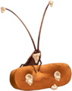

[WALL-E](https://dreamlightvalleywiki.com/WALL-E) Level 6

254

100000370



[WALL-E](https://dreamlightvalleywiki.com/WALL-E) Level 9

255

100000371

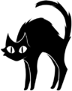

[***Villains' Star Path***](https://dreamlightvalleywiki.com/Villains%27_Star_Path)

256

100000372

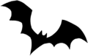

[***Villains' Star Path***](https://dreamlightvalleywiki.com/Villains%27_Star_Path)

257

100000373



[***Villains' Star Path***](https://dreamlightvalleywiki.com/Villains%27_Star_Path)

258

100000374



[***Villains' Star Path***](https://dreamlightvalleywiki.com/Villains%27_Star_Path)

259

100000375



[***Villains' Star Path***](https://dreamlightvalleywiki.com/Villains%27_Star_Path)

260

100000376



Villains' Star Path

261

100000377



Villains' Star Path

262

100000378



[***Villains' Star Path***](https://dreamlightvalleywiki.com/Villains%27_Star_Path)

263

100000379



[***Villains' Star Path***](https://dreamlightvalleywiki.com/Villains%27_Star_Path)

264

100000380



[***Villains' Star Path***](https://dreamlightvalleywiki.com/Villains%27_Star_Path)

265

100000381

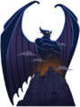

[*Villains' Star Path*](https://dreamlightvalleywiki.com/Villains%27_Star_Path)

266

100000382

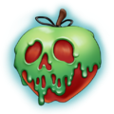

[*Villains' Star Path*](https://dreamlightvalleywiki.com/Villains%27_Star_Path)

267

100000383

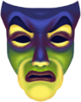

[*Villains' Star Path*](https://dreamlightvalleywiki.com/Villains%27_Star_Path)

268

100000384

[***Villains' Star Path***](https://dreamlightvalleywiki.com/Villains%27_Star_Path)



269

100000385



270

100000386

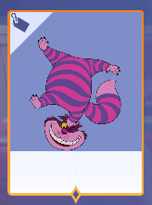

271

100000387

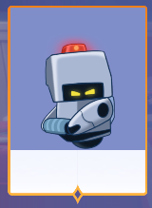

272

100000388



273

100000389

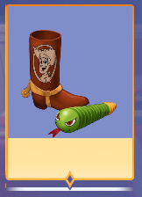

274

100000390



275

100000391

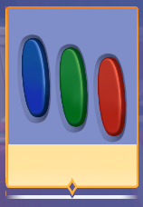

276

100000392

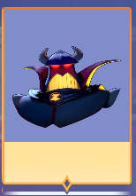

277

100000393

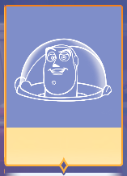

278

100000394

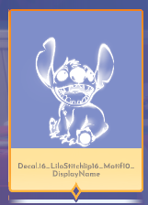

279

100000395

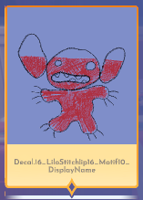

280

100000396

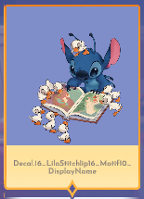

281

100000397

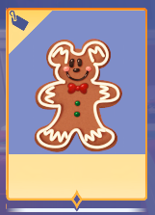

282

100000398

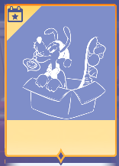

283

100000399



284

100000400

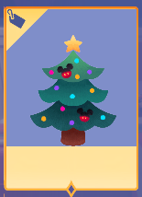

285

100000401



286

100000402

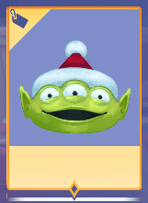

287

100000403

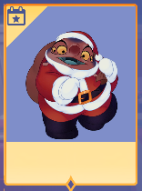

288

100000404



289

100000405

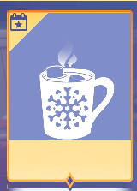

290

100000406

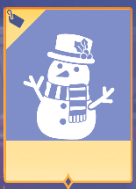

291

100000407

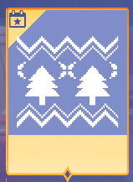

292

100000408



293

100000409



294

100000410

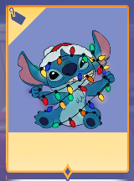

295

100000411

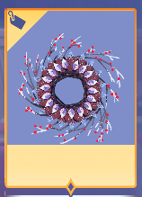

296

100000412

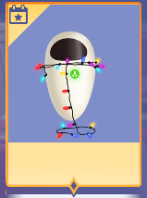

100000413

NÃO TEM NADA

297

100000414



298

100000415

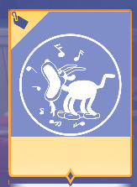

299

100000416

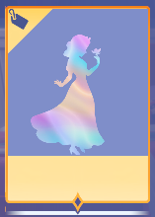

300

100000417

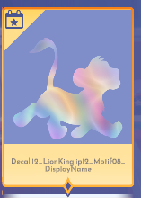

301

100000418

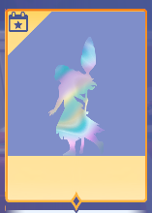

302

100000419

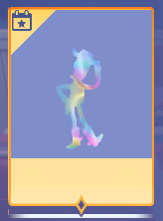

303

100000420

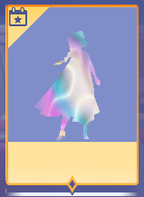

304

100000421



305

100000422

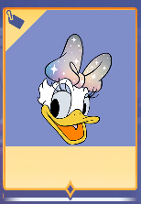

306

100000423

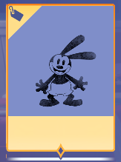

307

100000424

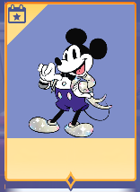

308

100000425

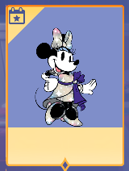

309

100000426

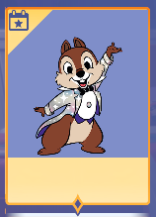

310

100000427

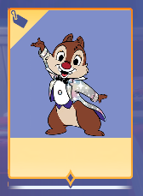

311

100000428

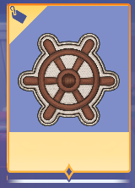

312

100000429

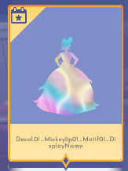

313

100000430



314

100000431

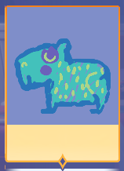

315

100000432



316

100000433

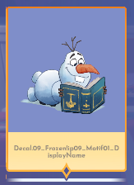

317

100000434



318

100000435

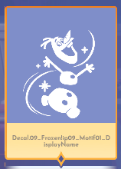

319

100000436

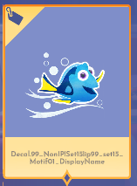

320

100000437

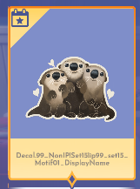

321

100000438

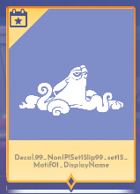

322

100000439

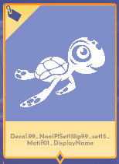

323

100000440

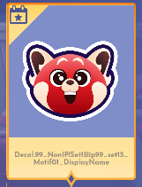

324

100000441

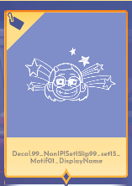

325

100000442

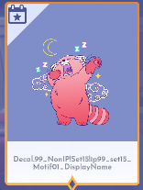

326

100000443

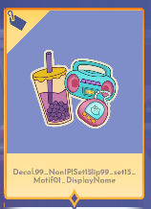

327

100000444



328

100000445

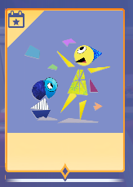

329

100000446

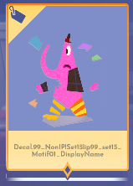

330

100000447

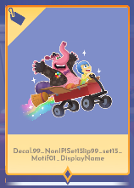

331

100000448

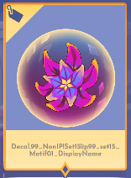

332

100000449

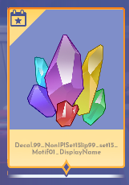

100000449

nada

333

100000450

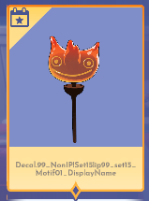

100000451

nada

334

100000452

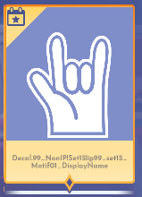

335

100000453



336

100000454



337

100000455



338

100000456



339

100000457

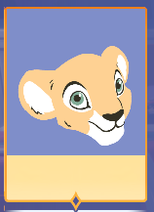

340

100000458



341

100000459

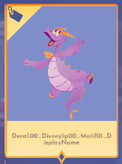

342

100000460

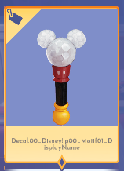

343

100000461

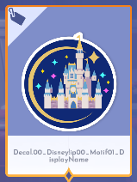

344

100000462

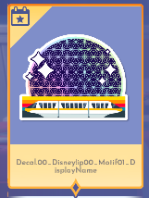

345

100000463

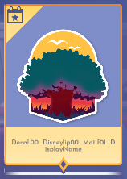

346

100000464

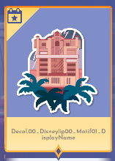

347

100000465



348

100000466

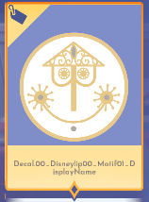

349

100000467

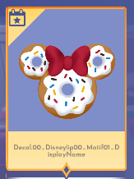

350

100000468

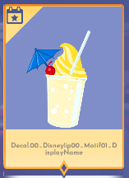

351

100000469

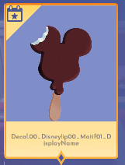

352

100000470

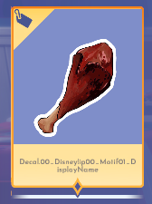

353

100000471

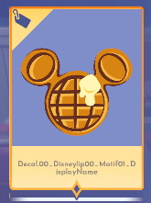

354

100000472

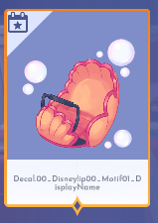

355

100000473

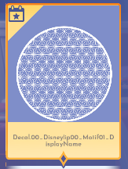

356

100000474

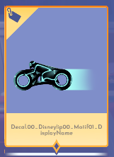

357

100000475



358

100000476

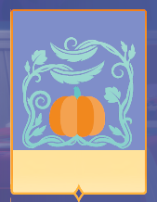

359

100000477

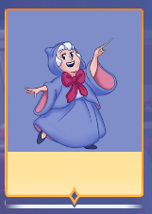

360

100000478

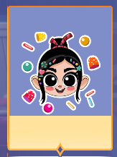

361

100000479

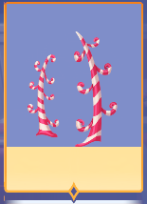

362

100000480

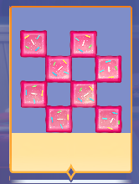

363

100000481

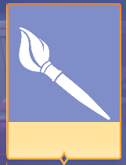

364

100000482



365

100000483



100000484

nada

100000485

nada

100000486

nada

366

100000487

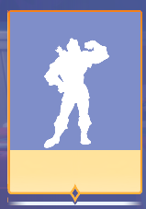

367

100000488

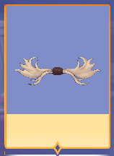

368

100000489

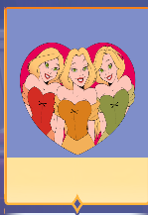

369

100000490

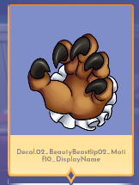

370

100000491

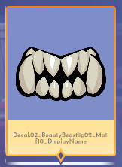

371

100000492



372

100000493

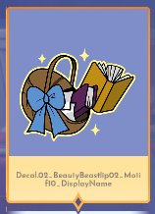

373

100000494

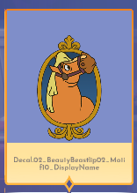

374

100000495

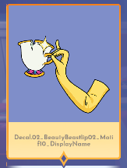

375

100000496

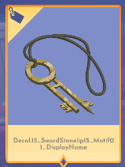

376

100000497

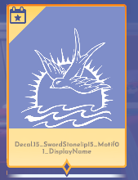

377

100000498



378

100000499

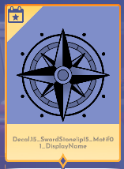

379

100000500

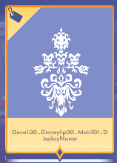

380

100000501



381

100000502

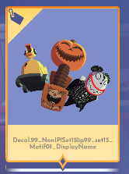

382

100000503

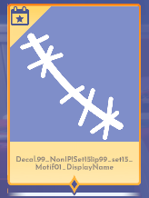

383

100000504

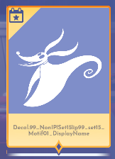

384

100000505

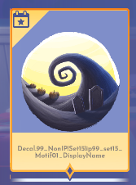

385

100000506

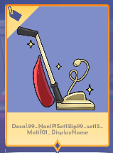

386

100000507

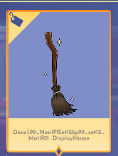

387

100000508

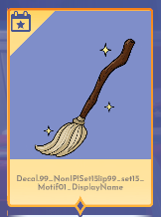

388

100000509

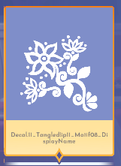

389

100000510

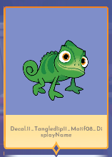

390

100000511

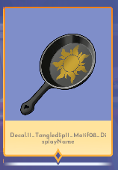

391

100000512

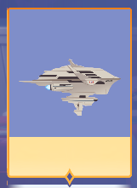

392

100000513



393

100000514

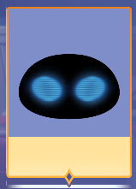

394

100000515

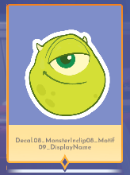

395

100000516



396

100000517

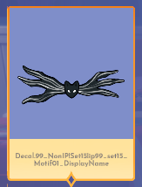

397

100000518

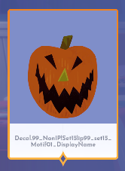

398

100000519

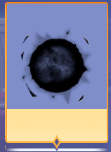

399

100000520

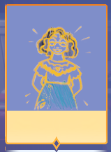

400

100000521

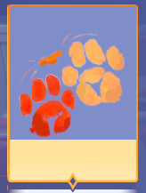

401

100000522

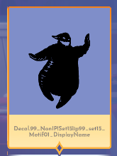

402

100000523

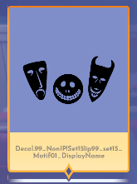

403

100000524

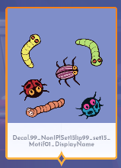

404

100000525

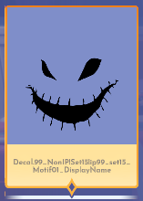

405

100000526

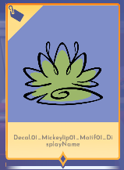

406

100000527



407

100000528

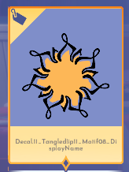

408

100000529



409

100000530

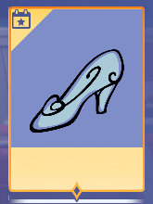

410

100000531

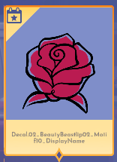

411

100000532

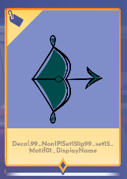

412

100000533

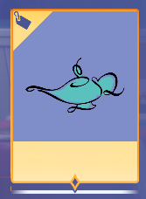

413

100000534



414

100000535

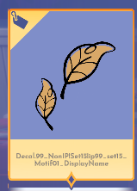

415

100000536

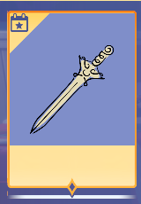

416

100000537

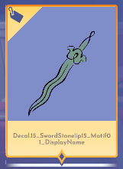

417

100000538

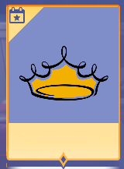

418

100000539

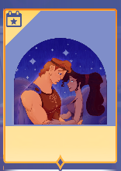

419

100000540



420

100000541

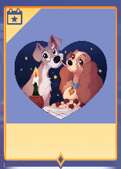

100000542

nada

421

100000543

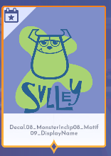

422

100000544



423

100000545

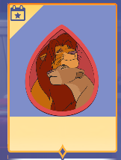

424

100000546

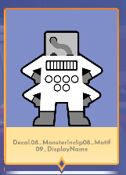

425

100000547

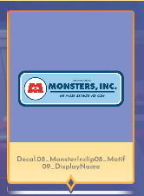

426

100000548

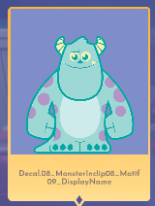

427

100000549

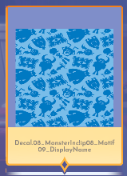

428

100000550

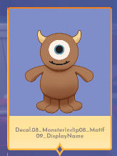

429

100000551

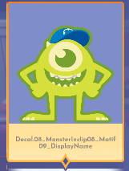

430

100000552



431

100000553



432

100000554

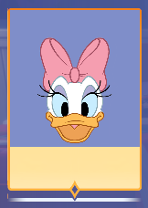

433

100000555

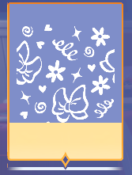

434

100000556

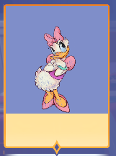

435

100000557

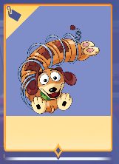

436

100000558

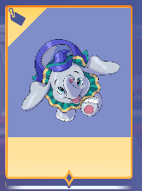

100000559

nada

437

100000560

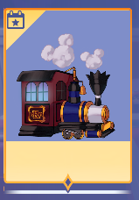

100000561

nada

438

100000562

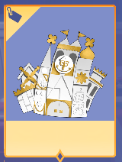

439

100000563

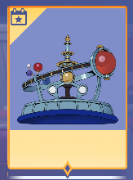

100000564

nada

440

100000565



441

100000566

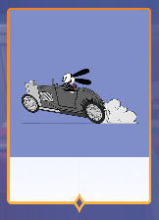

442

100000567

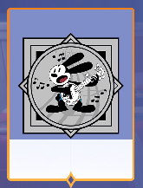

443

100000568

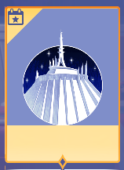

444

100000569

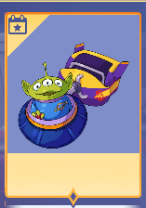

100000570

nada

445

100000571



446

100000572



447

100000573

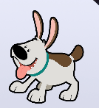

448

100000574



449

100000575

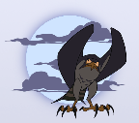

450

100000576



451

100000577



452

100000578

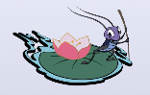

100000579

nada

453

100000580



454

100000581



455

100000582



456

100000583



457

100000584

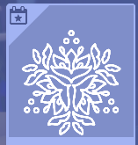

458

100000585



459

100000586



460

100000587

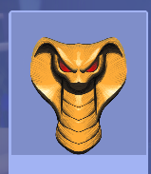

461

100000588

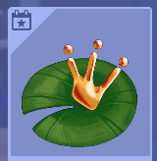

462

100000589



591

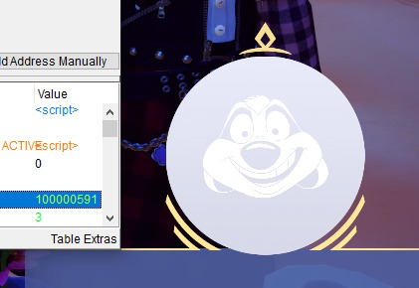

592

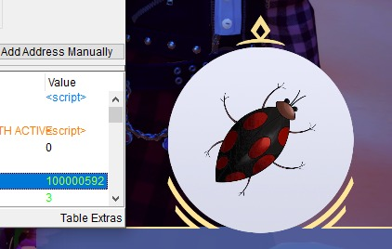

593

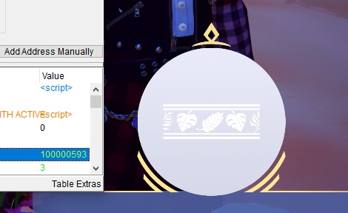

594

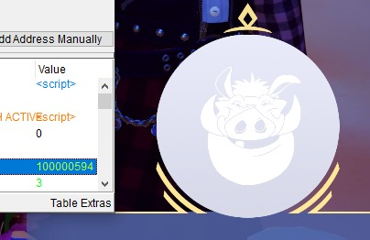

595

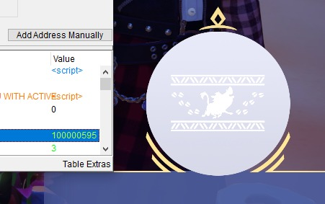

596

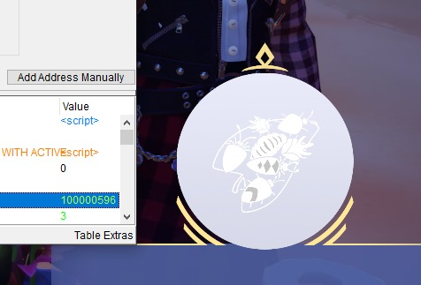

testei até 605 e mais nada

100000597

100000598

100000599

100000600

100000601

100000602

100000603

100000604

100000605

100000606

100000607

100000608

100000609

100000610

100000611

100000612

100000613

100000614

100000615

100000616

100000617

100000618

100000619

100000620

100000621

100000622

100000623

100000624

100000625

100000626

100000627

100000628

100000629

100000630

100000631

100000632

100000633

100000634

100000635

100000636

100000637

100000638

100000639

100000640

100000641

100000642

100000643

100000644

100000645

100000646

100000647

100000648

100000649

100000650

100000651

100000652

100000653

100000654

100000655

100000656

100000657

100000658

100000659

100000660

100000661

100000662

100000663

100000664

100000665

100000666

100000667

100000668

100000669

100000670

100000671

100000672

100000673

100000674

100000675

100000676

100000677

100000678

100000679

100000680

100000681

100000682

100000683

100000684

100000685

100000686

100000687

100000688

100000689

100000690

100000691

100000692

100000693

100000694

100000695

100000696

100000697

100000698

100000699

100000700

100000701

100000702

100000703

100000704

100000705

100000706

100000707

100000708

100000709

100000710

100000711

100000712

100000713

100000714

100000715

100000716

100000717

100000718

100000719

100000720

100000721

100000722

100000723

100000724

100000725

100000726

100000727

100000728

100000729

100000730

100000731

100000732

100000733

100000734

100000735

100000736

100000737

100000738

100000739

100000740

100000741

100000742

100000743

100000744

100000745

100000746

100000747

100000748

100000749

100000750

100000751

100000752

100000753

100000754

100000755

100000756